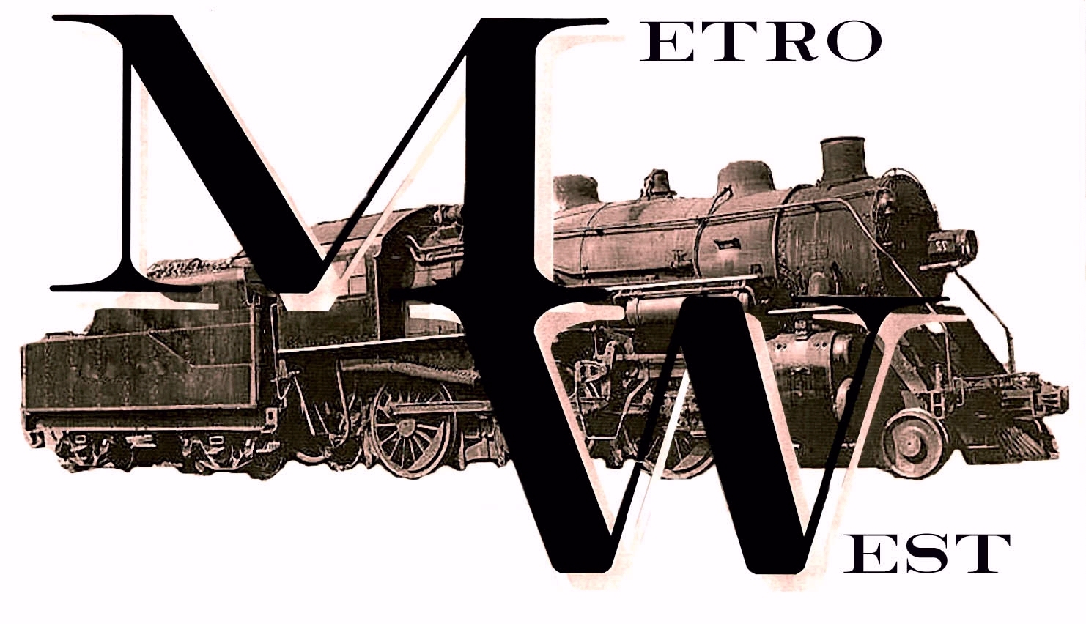

The Metrowest Model Railroading Society
A Not-For-Profit Organization
Proudly Presents…

O And S Scale Train Show
SUNDAY, JULY APRIL 10th, 2016
Hudson Elk’s Hall
99 Park Street Hudson, MA 01749

Ticket prices:
$6 – Adults
$8 – Family Maximum

+ 2 Rail O Scale
+ 2 Rail S Scale
+ 3 Rail O Scale (Hi-Rail)
+ 2 Rail S Gauge American Flyer
+ Narrow Gauge (Yes! Both O and S)
+ S and O Scale Door Prizes
+ Books and Videos
+ Operating On-Site Modular Layout
+ Refurbished, Bright New Display Hall
+ Close to Boston and Historic Sites

For More Information Contact:

Larry Grant

347 Balcom Street
Mansfield, MA 02048
Phone: 508-337-6661
BigBrotherLar@netzero.net
www.trainweb.org/metrowest
Show Hours: 10 A.M. to 4 P.M.

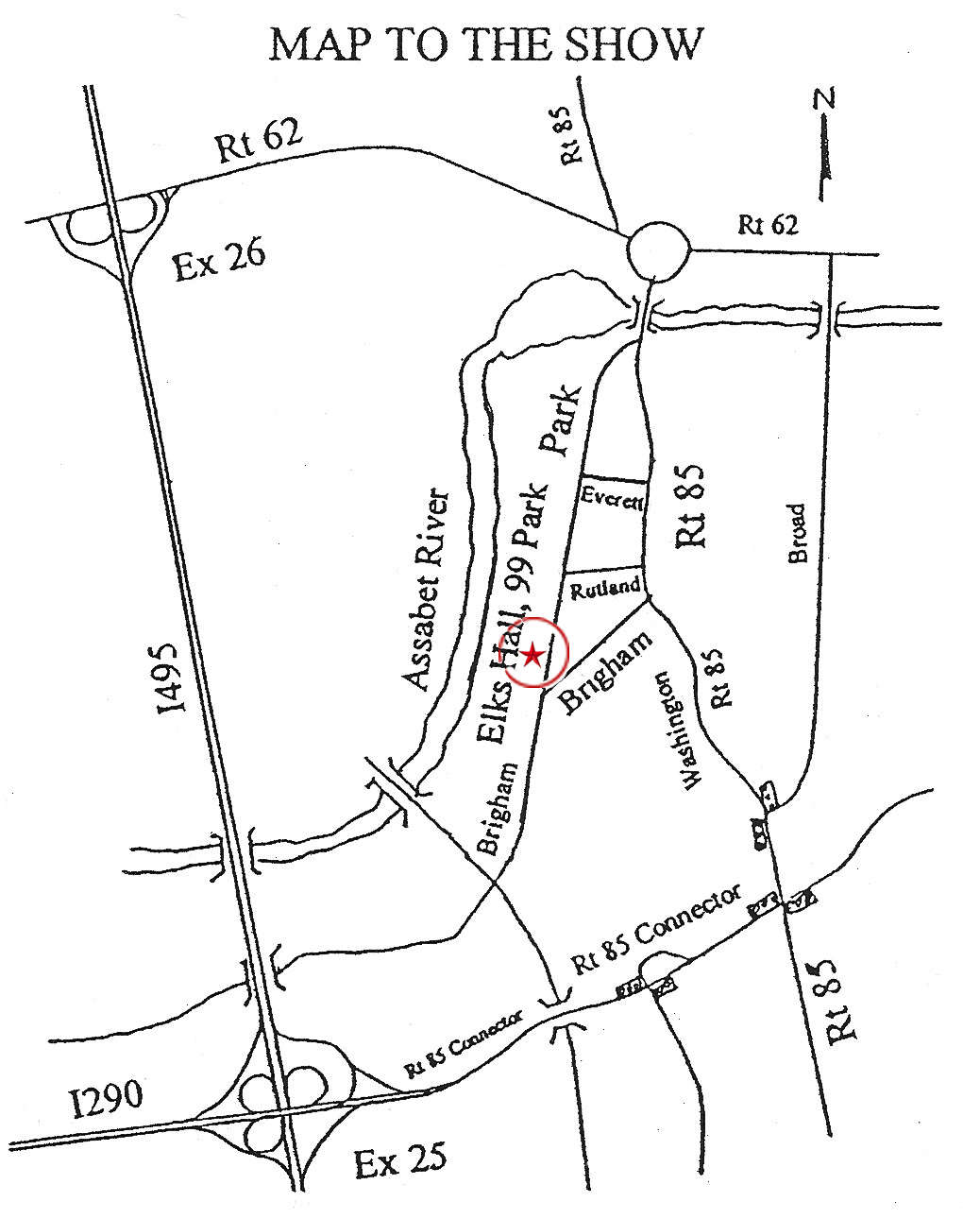

DEALER INFORMATION

FULL PAYMENT MUST BE RECEIVED BY FRIDAY, JULY 1st, 2016. Partial payment does not guarantee a table reservation. Please make your check payable to Metrowest Model Railroad Society and send to Larry to reserve your table(s).

Tables are six (6) feet long by thirty (30) inches wide.
Prices shown are good prior to June 13, 2016. On or after June 13, 2016, please add $5 per table. If you need help with loading and unloading, just ask one of the friendly Metrowest members for a hand.

Prior to June 13, 2016 On or After June 13, 2016
$20 per six (6) foot table $25 per six (6) foot table

Dealer setup starts at 6:30 AM on Sunday, JULY 10th, 2016.

 LOST? Call 508-241-1296

_ _ _ _ _ _ _ _ _ _ _ _ _ _ _ _ _ _ _ _ _ _ _ _ _ Detach here and mail to Larry _ _ _ _ _ _ _ _ _ _ _ _ _ _ _ _ _ _ _ _ _ _ _ _ _ _ _ _ _ _ _ _ _ _

Name: _________________________________________________________________________________________________

Street: _________________________________________________________________________________________________

City: _____________________________________________________________ State: __________ Zip: _____________

Phone: (______) _______ --- _____________ Email: _____________________________________ MA Tax ID # ________________

Scale: O S BOTH Number of 6 Foot Tables: ________ Require Electricity? Y N

Special Requests: ________________________________________________________________________________________________
MMRS 2016-2 We look forward to working with you. See you at the show!

